pairs(mtcars, panel = panel.smooth, main = "mtcar data", col = 3 + (mtcars$am))

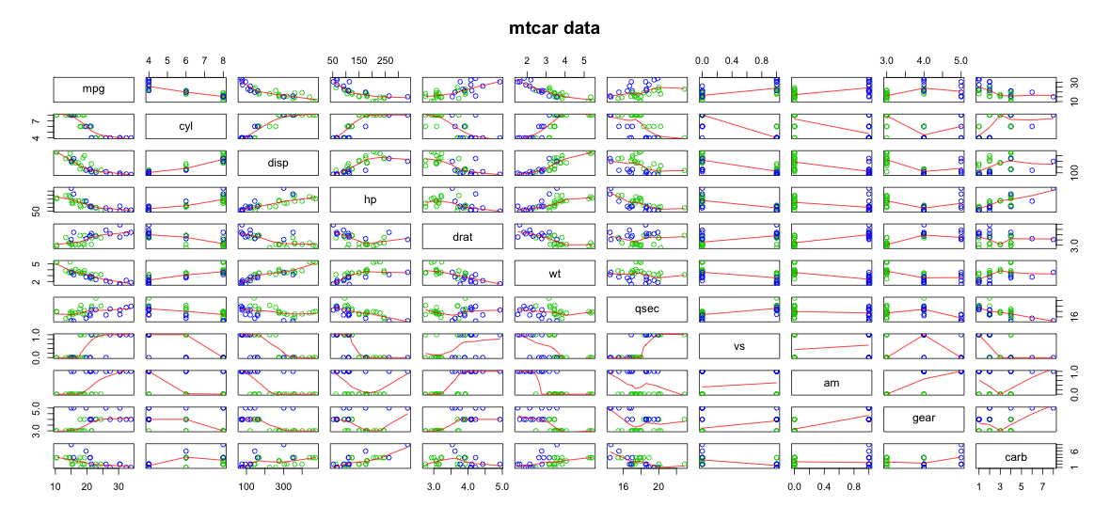

> summary(lm(mpg~.,mtcars))

Call:

lm(formula = mpg ~ ., data = mtcars)

Residuals:

Min 1Q Median 3Q Max

-3.4506 -1.6044 -0.1196 1.2193 4.6271

Coefficients:

Estimate Std. Error t value Pr(>|t|)

(Intercept) 12.30337 18.71788 0.657 0.5181

cyl -0.11144 1.04502 -0.107 0.9161

disp 0.01334 0.01786 0.747 0.4635

hp -0.02148 0.02177 -0.987 0.3350

drat 0.78711 1.63537 0.481 0.6353

wt -3.71530 1.89441 -1.961 0.0633 .

qsec 0.82104 0.73084 1.123 0.2739

vs 0.31776 2.10451 0.151 0.8814

am 2.52023 2.05665 1.225 0.2340

gear 0.65541 1.49326 0.439 0.6652

carb -0.19942 0.82875 -0.241 0.8122

---

Signif. codes: 0 ‘\*\*\*’ 0.001 ‘\*\*’ 0.01 ‘\*’ 0.05 ‘.’ 0.1 ‘ ’ 1

Residual standard error: 2.65 on 21 degrees of freedom

Multiple R-squared: 0.869, Adjusted R-squared: 0.8066

F-statistic: 13.93 on 10 and 21 DF, p-value: 3.793e-07

> dim(mtcars)

[1] 32 11

> fit <- lm(mpg~.+factor(am) -1,mtcars)

> confint(fit)

2.5 % 97.5 %

cyl -2.28468553 2.06180457

disp -0.02380146 0.05047194

hp -0.06675236 0.02378812

drat -2.61383350 4.18805545

wt -7.65495413 0.22434628

qsec -0.69883421 2.34091571

vs -4.05880242 4.69432805

am -23.34282753 52.99002962

gear -2.44999107 3.76081711

carb -1.92290442 1.52406591

factor(am)0 -26.62259745 51.22934576

factor(am)1 NA NA

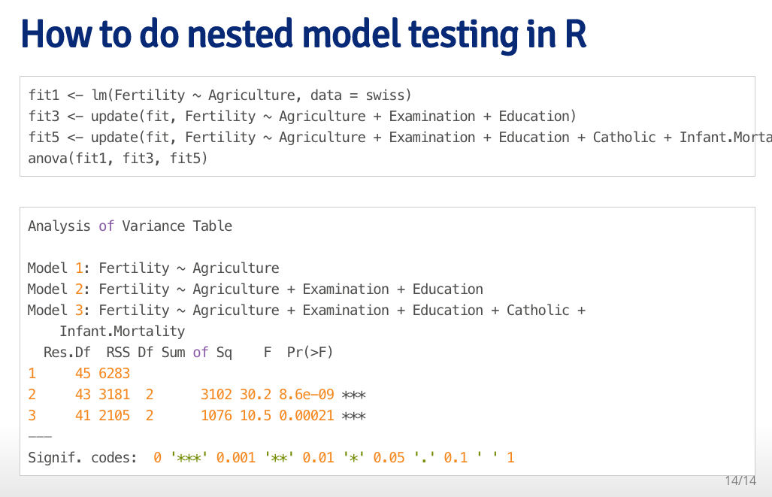

Correlations of data

> cor(mtcars)

mpg cyl disp hp drat wt qsec vs

mpg 1.0000000 -0.8521620 -0.8475514 -0.7761684 0.68117191 -0.8676594 0.41868403 0.6640389

cyl -0.8521620 1.0000000 0.9020329 0.8324475 -0.69993811 0.7824958 -0.59124207 -0.8108118

disp -0.8475514 0.9020329 1.0000000 0.7909486 -0.71021393 0.8879799 -0.43369788 -0.7104159

hp -0.7761684 0.8324475 0.7909486 1.0000000 -0.44875912 0.6587479 -0.70822339 -0.7230967

drat 0.6811719 -0.6999381 -0.7102139 -0.4487591 1.00000000 -0.7124406 0.09120476 0.4402785

wt -0.8676594 0.7824958 0.8879799 0.6587479 -0.71244065 1.0000000 -0.17471588 -0.5549157

qsec 0.4186840 -0.5912421 -0.4336979 -0.7082234 0.09120476 -0.1747159 1.00000000 0.7445354

vs 0.6640389 -0.8108118 -0.7104159 -0.7230967 0.44027846 -0.5549157 0.74453544 1.0000000

am 0.5998324 -0.5226070 -0.5912270 -0.2432043 0.71271113 -0.6924953 -0.22986086 0.1683451

gear 0.4802848 -0.4926866 -0.5555692 -0.1257043 0.69961013 -0.5832870 -0.21268223 0.2060233

carb -0.5509251 0.5269883 0.3949769 0.7498125 -0.09078980 0.4276059 -0.65624923 -0.5696071

am gear carb

mpg 0.59983243 0.4802848 -0.55092507

cyl -0.52260705 -0.4926866 0.52698829

disp -0.59122704 -0.5555692 0.39497686

hp -0.24320426 -0.1257043 0.74981247

drat 0.71271113 0.6996101 -0.09078980

wt -0.69249526 -0.5832870 0.42760594

qsec -0.22986086 -0.2126822 -0.65624923

vs 0.16834512 0.2060233 -0.56960714

am 1.00000000 0.7940588 0.05753435

gear 0.79405876 1.0000000 0.27407284

carb 0.05753435 0.2740728 1.00000000

Cyl and Disp seem correlated – use Cyl

Wt highest

HP also correlated to Cyl